Date Request Email Template
Stage: Sales – Dates & Logistics

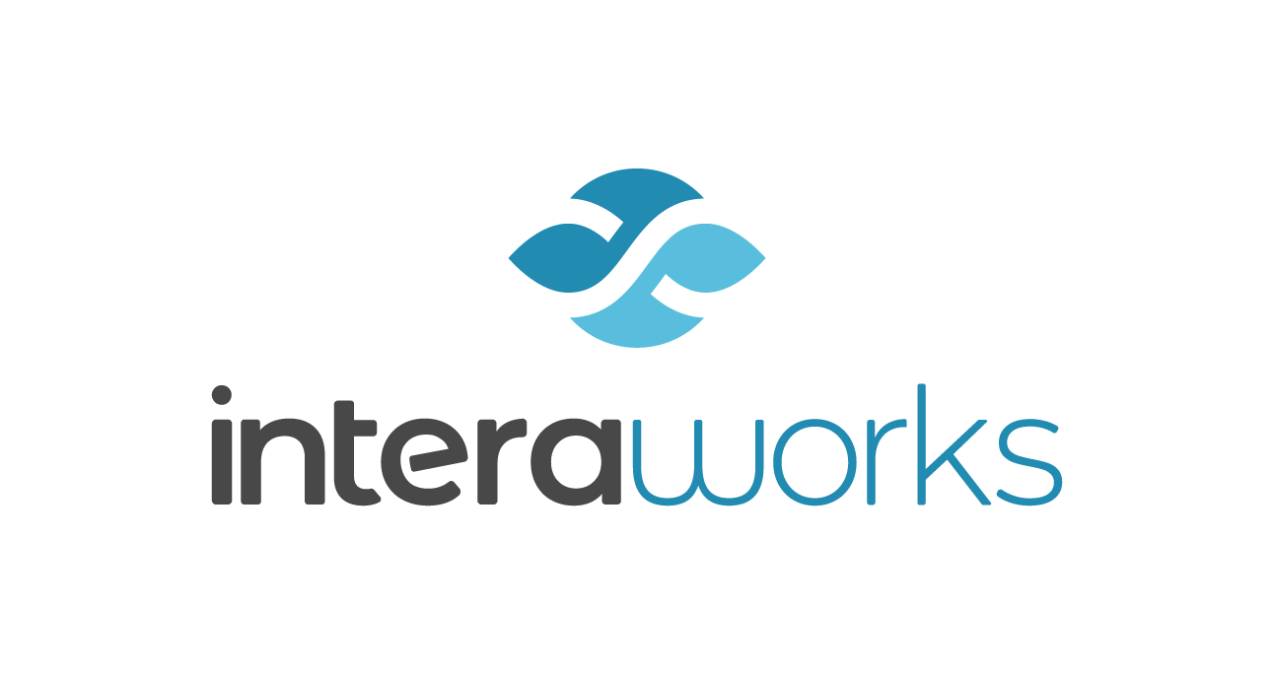

Hello CLIENT,
We’re excited that you’ve chosen to book a PROGRAM NAME workshop! I will be your point of contact through this logistics process.

I understand that you are looking to book DESCRIPTION OF NEED. Here are our available dates:
- MONTH: XX
- MONTH: XX
Once we have selected a date, our legal lead Charity Wilkins (charity.wilkins@interaworks.com), will send over a contract to confirm via DocuSign. If you are unable to use DocuSign or have any concerns, we can also share the contract via email.
Please note: This program is for Outlook for PC users only. If you have participants on a Mac or Outlook Web Access (OWA), please let us know and we can recommend an alternative program to support those learners.
I look forward to hearing back from you and please let me know if you have any questions!

Thanks,

